1. What is a Computer?

A computer is an electronic device that takes in data as its input through its input hardware, loads the data into memory for execution, executes the data with the help of the central processing unit (CPU) into information, and stores the information on secondary memory that is non volatile or outputs information for user by the user.

1. What are the main components of a computer?

* Central processing unit.
* Hardware.
* Software.
* Data and instructions.

1. What is Computer hardware?

These are electronic and tangible parts of the computer. Computer uses hardware to connect to peripheral devices, input data and output information. Some hardware components are illustrated below.



Hardware can be categorized into;

1. Drives; these are used for secondary storage. For example Diskette, hard Disk and optical drives.
2. Input; these are used to input data into the computer. For example keyboard, Mouse, Scanner and a digital camera.
3. Memory; these are for primary data storage. They store data and instructions during execution and they are volatile, for example the registers.
4. Output; These help to put out information for use by the user, for example a printer.
5. Well, some hardware can be used as both input and output, for example during conversion of text to sound, sound devices act as output devices for example ear piece. During conversion of sound to text, sound devices act as input for example the mouth piece of a mobile phone. Another example is using a microphone and a speaker.
6. CPU; this is hard ware that carries out arithmetic and login operation, and controls other processes within the computer system. it can encode and decode instructions.

A motherboard has the inner hardware of the computer system. for example the memory chips and the CPU.

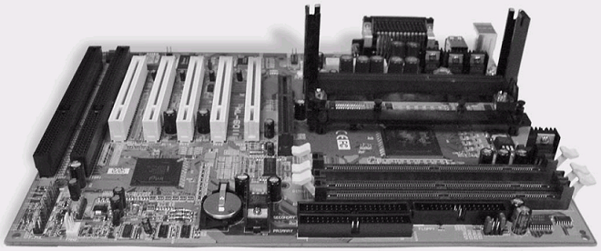

1. How do these devices communicate with the computer system?

When a device is connected to the computer system either using a universal serial bus (USB) or wireless connection, the device controller sends an interrupt vector to the operating system to specify the device drivers necessary for that hardware; the device driver loads the registers for that hardware into the device controller which the starts data transmission through the system bus. When transmission is done, the device controller sends another interrupt to the operating system such that it can take back the resources (registers).